**Integration Documentation: Connecting Excel to MySQL Database**

**Overview**

This document provides detailed instructions for establishing a connection between Microsoft Excel and a MySQL database using the MySQL Connector/NET and MySQL Connector/ODBC drivers. This setup will allow you to import data from the MySQL database into Excel for analysis and visualization.

**Prerequisites**

Microsoft Excel (version 2016 or later)

MySQL Database (configured and accessible)

MySQL Connector/NET 9.0.0 (downloaded and installed)

MySQL Connector/ODBC 9.0.0 (64-bit) (downloaded and installed)

**Step 1: Install MySQL Connector/NET**

Download MySQL Connector/NET 9.0.0:

Ensure the file mysql-connector-net-9.0.0.msi is downloaded.

Double-click the .msi file to begin the installation process.

Follow Installation Steps:

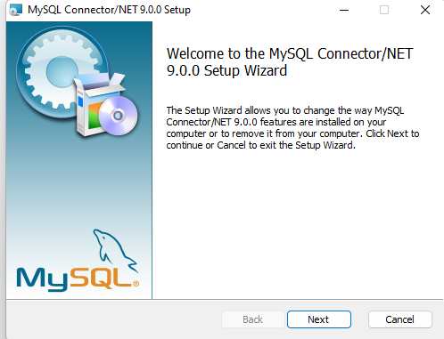

Click "Next" on the initial setup screen.

Accept the license agreement and click "Next."

Choose the setup type (typically "Typical" for most users).

Click "Install" to complete the installation.

Confirm Installation:

Once installed, the MySQL Connector/NET allows .NET applications (like Excel) to communicate with the MySQL database.

Restart Excel to ensure the connector is properly loaded.

**Step 2: Install MySQL Connector/ODBC**

Download MySQL Connector/ODBC 9.0.0 (64-bit):

Ensure the file mysql-connector-odbc-9.0.0-winx64.msi is downloaded.

Double-click the .msi file to begin the installation process.

Follow Installation Steps;

Click "Next" on the initial setup screen.

Accept the license agreement and click "Next."

Choose the setup type (typically "Typical").

Click "Install" to complete the installation.

Confirm Installation:

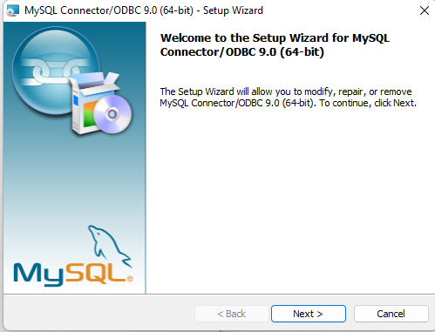

After installation, the ODBC driver will be available for creating DSN (Data Source Name) connections.

**Step 3: Create a DSN (Data Source Name)**

Open ODBC Data Source Administrator:

Go to the Windows Start Menu and search for "ODBC Data Sources (64-bit)."

Open the ODBC Data Source Administrator tool.

Add a New Data Source:

In the "User DSN" or "System DSN" tab, click "Add."

Select "MySQL ODBC 9.0 ANSI Driver" (or "MySQL ODBC 9.0 Unicode Driver") and click "Finish."

Configure the MySQL DSN:

Data Source Name: Enter a name for your DSN (e.g., "MySQL_Excel_Connection").

Description: (Optional) Provide a description.

Server: Enter the MySQL server address (e.g., localhost or an IP address).

User: Enter your MySQL username.

Password: Enter your MySQL password.

Database: Select the database you want to connect to from the dropdown menu.

Test the Connection:

Click "Test" to ensure the connection is working.

If the test is successful, click "OK" to save the DSN.

**Step 4: Connect Excel to MySQL Database**

Open Excel:

Start Microsoft Excel and open a new or existing workbook.

Get External Data:

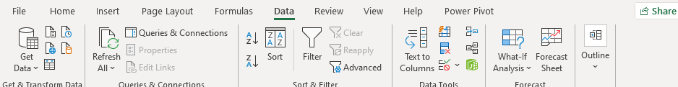

Go to the "Data" tab in the Excel ribbon.

Click "Get Data" > "From Other Sources" > "From ODBC."

Select DSN:

In the "ODBC Data Source" window, select the DSN you created earlier (e.g., "MySQL_Excel_Connection").

Click "OK."

Enter MySQL Credentials:

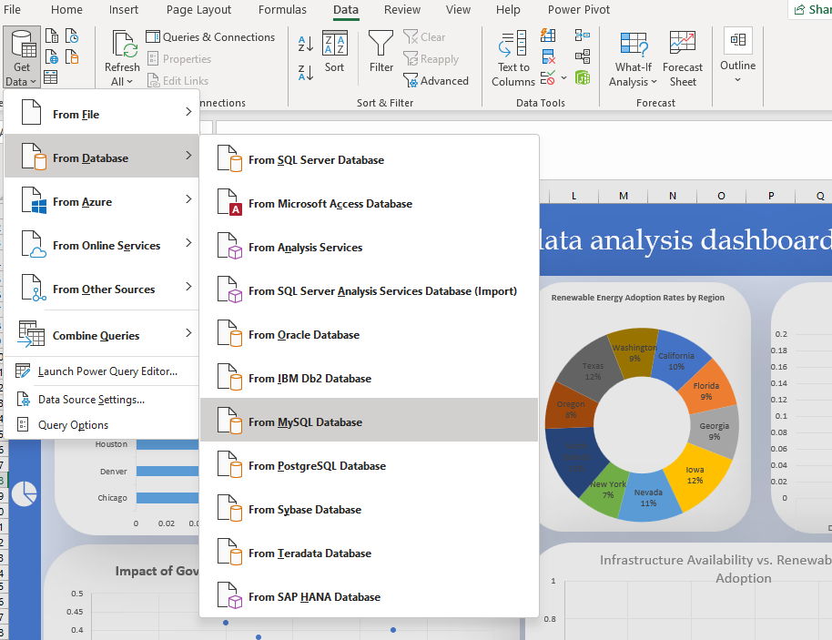

If prompted, enter your MySQL username and password.

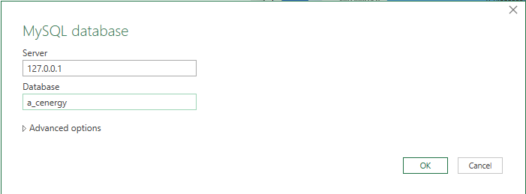

Click "Connect."

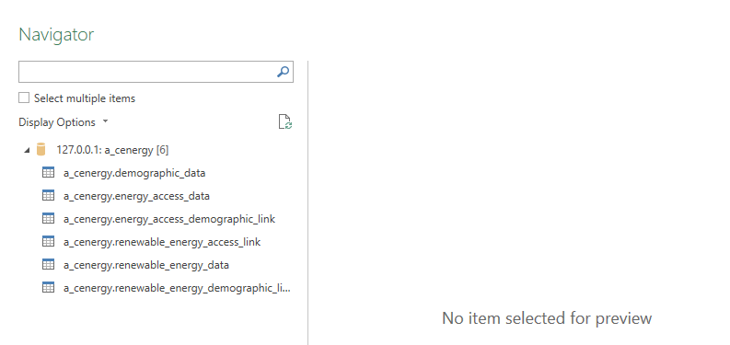

Select Database and Tables:

In the "Navigator" window, select the database and tables you want to import.

Click "Load" to import the data into Excel.

**Step 5: Verify Data Import and Begin Analysis**

Review Imported Data:

Ensure that the data is imported correctly into Excel.

Check for any discrepancies or formatting issues.

Begin Analysis:

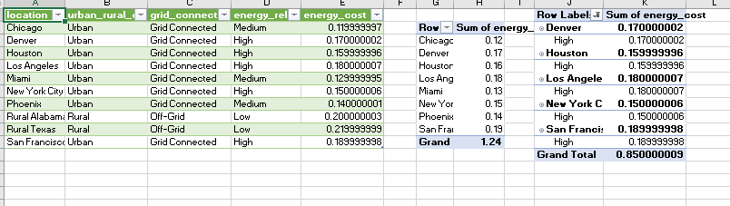

Use Excel’s tools like pivot tables, charts, and the Data Model to analyze the imported data.

Create the visualizations and dashboards as required by your project.

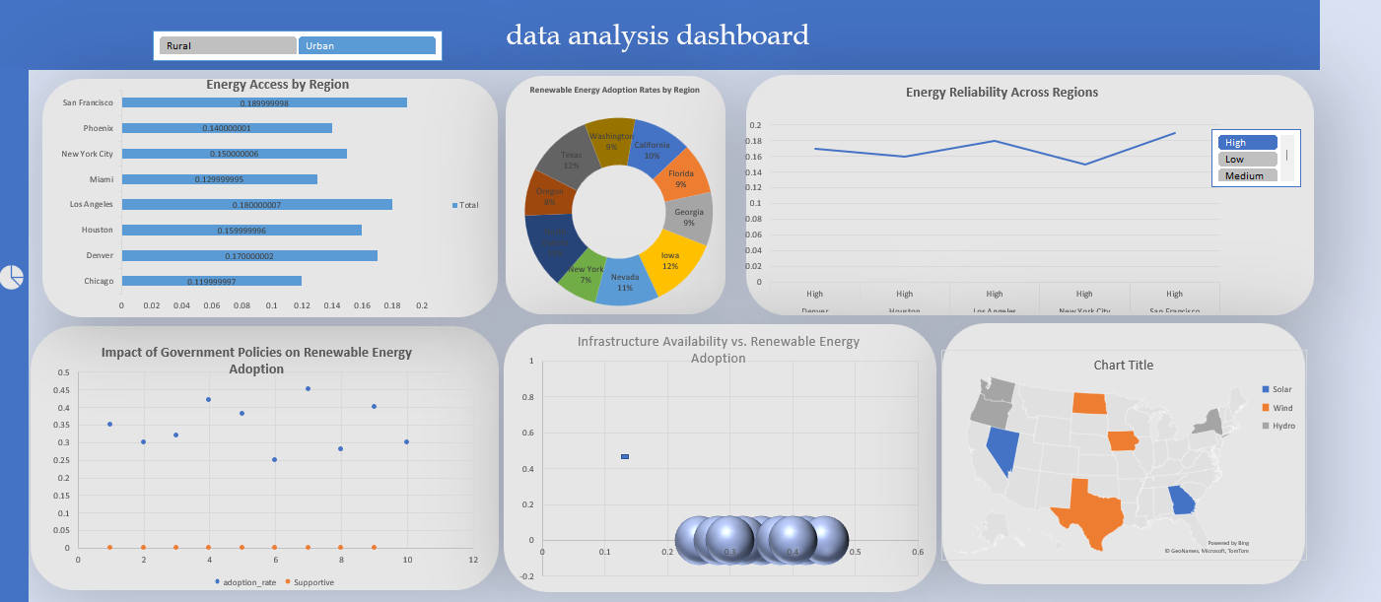

Troubleshooting Tips

Connection Issues: Ensure that the MySQL server is running and that the firewall allows connections on the MySQL port (default is 3306).

ODBC Driver Not Listed: If the MySQL ODBC driver is not listed, ensure that you installed the 64-bit version on a 64-bit system or 32-bit on a 32-bit system.

Excel Crashes: Restart Excel after installing the connectors to ensure all changes take effect.

Conclusion

By following this documentation, you should be able to successfully connect Microsoft Excel to your MySQL database, enabling you to import and analyze data directly in Excel. This integration will be essential for visualizing key insights and creating interactive dashboards.